MAGIC PHRASES FRAMEWORK 7.0 (with prompts)

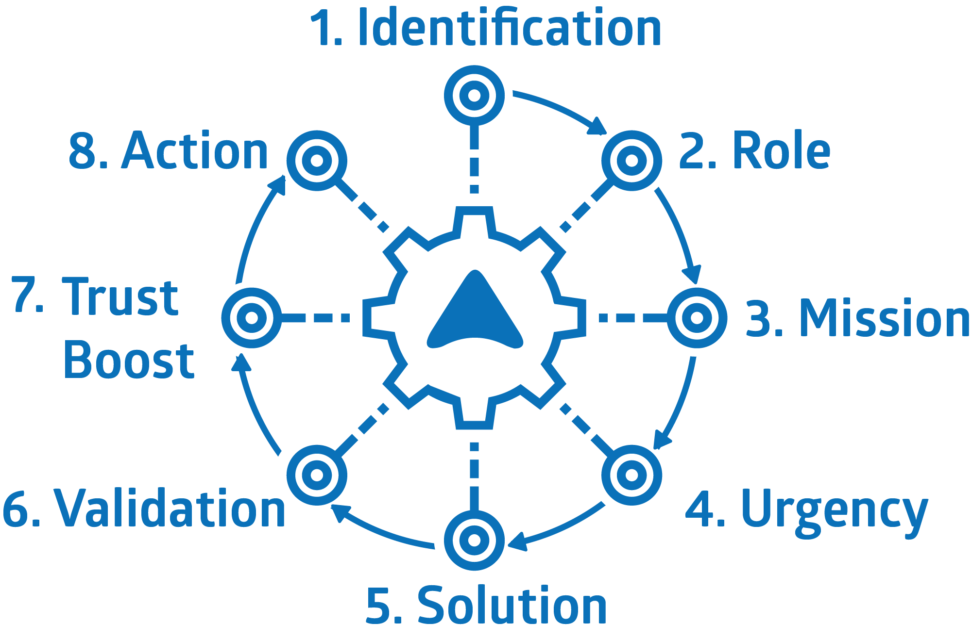

PREPARATION

To get the most from your Elevator Speech Training session,
we highly recommend you prepare.

  - On the following pages, you will find a two-column framework for an informal, three-minute spoken communication, for example, for pitching an idea to potential funders.
  - To prepare for your training session, please write a brief script of your pitch by filling in blanks in the left column in the step-by-step framework (starting on page 3).
  - Follow the prompts in the right column of the framework as you go through the eight segments.
  - After drafting your script, go through the checklist on page 9 to make sure you covered the basics.
  - With your draft pitch added to this document, save it, and, ideally, send it to prep@est.io no later than 24 hours before your session.
  - Instead of this document you can also use the online version of this worksheet at www.theworksheet.org.
STEP-BY-STEP FRAMEWORK

Before you fill in the blanks in the left column below, pick a communications scenario that is critical to you,
and specify your audience, for example: “Talking with potential funders.” Take a look at the example pitch on page 6 for reference.
“Hello, my name is... | 1 – Identification  Example: “Hello, my name is Jane Doe.”
I am... | 2 – Role  Example: “I’m the CEO of Healthy Babies, the largest US non-profit focused on infant health.”  This segment is not just about saying who you are but also about "pegging" yourself and your organization (if appropriate). If your organization has a special ranking in some important regard (size; being the first or only one of its kind; the oldest etc.), mention it–briefly–here to get more attention.
Our goal is... | 3 – Mission  Example: “Our goal is to get rid of toxic chemicals in the foods babies eat and the things they touch so they will live healthy lives.” – Use conversational language that a 14-year-old would understand. Don’t just copy and paste the mission statement on your website. Avoid expert language and jargon. Touch on what you do ("getting rid of toxic chemicals" in the example above) in the beginning of the sentence but keep it short and limited to one thing, then mention the outcome ("health lives"). Again, the briefer, the better because you want to get to talking about why it matters (see next step below) as quickly as possible.
Listen, we’re facing a big challenge. | 4 – Urgency  Prime your listeners by beginning with a brief dramatic signpost phrase (a heads-up about what you will say next). For example: "Listen, we're facing the challenge of our lifetime!" (Feel free to adapt this but keep it a brief sentence; right after it, pause for a moment.) Then, summarize the urgency in one or two short sentences. Try to point to a positive opportunity within grasp first, but then land on the urgent problem remaining. For example, "Humanity already has all the technology needed to deal with climate change successfully. But insufficient action is still threatening our very survival." The goal is to create a frame of urgency and make the first signal positive before pointing to the problem. This approach is essential in an age when more and more people tune out when confronted with catastrophic information only.  Give a couple concrete and shocking examples or data points for the challenge, ideally with a perspective of change over time or comparison to what is normal so they have meaning. For example: "For example: The last 7 years have been the warmest on record. Dozens of species of plants and animals currently go extinct each day — nearly 1,000 times the natural rate."  Follow the example with a sentence that begins with “It makes me feel [use an action-oriented emotion like “deeply concerned.” Avoid conveying stifling feelings like “depressed” or “helpless”. For example: "It's upsetting and makes me deeply concerned."  Wrap up the “urgency segment” with a sentence using the pattern of “What’s at stake here is A, and ultimately, B!” Make B bigger than A to form a crescendo.  Don’t just repeat your mission but take it to a higher level. Give people goosebumps. Use a positive and not a negative. I.e., at stake is what you want to achieve, not what you want to avoid.  For example: “What’s at stake here is strong and resilient communities, and ultimately, the future of our country.”
So, here’s what we do at… | 5 – Solution  Use another signpost phrase, so your listeners know that you’re shifting to talking about the solution. For example: “So, here’s what we do at XYZ organization [pause].”  Summarize your solution in a brief sentence to avoid information overload. For example, if you work in three areas, say: “Our work falls into three buckets: A, B, and C.” Avoid complexity!  Now, articulate your “secret sauce,” i.e., what is unique about your approach, what gives you an edge, and what makes you different from similar organizations  Please make sure it is unique and not generic.  Often, a combination of two or three (no more) ingredients can create uniqueness.  For example: "So, we have a unique secret weapon. It's that we are both, policy advocates and actual builders of affordable housing."  Here another example: "So, we have a unique secret weapon. It's the incredible diversity of expertise we have assembled under one roof."  Give your secret sauce a name to make it more real, for example, "Community Impact Model". Instead of "model" you can use nouns like effect, paradigm, playbook, framework, etc.  Now, tell a specific story about an actual situation where your secret sauce created a positive outcome. A common mistake at this point is giving just another summary. Instead, offer concreteness: Begin the story with a dramatic obstacle. Show how your secret sauce overcomes it and creates a happy ending. Add "signs of realness." For example, take listeners to a concrete moment in time. Or feature a specific person, with a name, and maybe even a description of what they looked and sounded like at that point.  Begin with words like “here’s a story that shows how well our approach works.”  IMPORTANT: Please make sure the ingredients of your secret sauce show up clearly in your story to make it genuinely illustrative of the power of your unique approach.  After telling your story, finish with a sentence like: “This story illustrates how our unique approach of [doing xyz] makes all the difference.”
We’ve had consistent impact using this approach. For example, … | 6 – Validation  Instill confidence by listing past successes, well-known partners, etc. Use a signpost phrase like: “We have had consistent impact using this approach, for example, ...”  Keep this brief. Think of it as ticking off three quick success metrics using the fingers of your hand. Do not tell another story here.  A common mistake at this point is being vague. Instead, mention concrete numbers or use a quote. For example: "Over the last three years we've worked with 25 school districts, including the three largest in the country. The New York Times has called us 'the best thing since sliced bread in education.'"
This work is personal to me because… | 7 – Trust Boost  What is something unexpectedly candid related to your work that you can share to get a trust boost from your listeners? (Begin with a signpost phrase like "This work is personal.")  The goal of this segment is to trust your listeners with an unexpectedly candid piece of personal information, causing them to “trust you back” (which will make them more receptive to your “asks” in the final step).Use a signpost phrase so your listeners know you’re shifting to talking about why what you do is personal to you. For example: “This work is personal to me [pause].” This is NOT about talking about successes and good fortune. The critical thing here is to share something that is genuinely candid, requiring a bit of courage to share because it makes you a bit vulnerable. Apart from regret, candor can also come in the form admitting ignorance, or having had to learn something the hard way. Try to begin a sentence with "To be frank..." and it may lead you to genuine frankness. It’s essential to keep this short and focused on just one point. Here is an example: "This works is personal. I used to be a vice president at a hedge fund. The job made me a lot of money. To be frank, it also made me profoundly unhappy. I saw my therapist at least twice a week. When a friend helped me find my calling here, my life was transformed."
So, here’s what you can do: | 8 - Action  Use a signpost phrase like “So here’s what you can do [pause].”  Suggest specific and actionable things to do. Don’t force your audience to have to translate your directives into action.  Explain concrete next steps with an uncommon level of detail to convey your earnestness of wanting to engage. For example, say your phone number out loud, slowly, extra clearly, and twice as if it is a code for saving the world.  Be confident and direct. Avoid conditional phrases like “If you’re interested, then….”  Know in advance the forward-looking sentence you will say right after “thank you.” Make it count. Make it strong.  For example: “Thank you. And I’m looking forward to what we will do together.”  Having that forward-looking sentence at the very end makes for a more confident ending, as opposed to just saying "thank you" followed by an awkward silence.
EXAMPLE PITCH
IDENTIFICATION & ROLE
Hi, my name is Marc Fest. I am the founder of Elevator Speech Training.
MISSION
I help my clients communicate successfully in critical situations, for example, when they talk to potential donors. I use a simple eight-step framework that makes it possible for them to learn how to avoid the most common mistakes in just one training session.
PROBLEM
Here's the problem: We live in a world that desperately needs positive change. But even high-level change-makers usually don’t take the time to optimize their pitch about what they do. I see all the time how much better they get after just 60 minutes of coaching. I'm concerned about the tremendous amount of ability that’s dormant here. What's ultimately at stake here is unleashing the full ability of the people fighting on the frontlines of the world's most urgent challenges.

SOLUTION
Our solution is an 8-step “Elevator Speech Framework.” It enables anybody to make breakthrough improvements in talking about what they do in just one or two training sessions. Its “secret sauce” is a set of fill-in-the-blank prompts that prevent the most common mistakes. For example, to fix the typical lack of urgency in a pitch, it calls for emphasizing the importance of your work right in the beginning, culminating in a sentence that begins with the words "What's ultimately at stake here is…" It's a paint-by-numbers approach that may at first seem formulaic and deceptively simple. But its impact on how you communicate will be powerful and lasting.

VALIDATION
We have many well-known clients, for example, the Ford Foundation and Carnegie Corporation who have us train staff and grantees. We also work with organizations like Harvard and Tufts University. More than 70 CEOs and Executive Directors have endorsed the training.

PERSONALIZATION
This work is personal to me. I struggle with anxiety about things from climate change to nuclear war. But when I work with clients who are trying to make a positive difference in this universe, I feel better and calmer afterward. In a way, my work is like therapy for me. But it’s not about me. As I said, it’s about our collective ability to make the world a better place.

CALL TO ACTION
So here is what you can do: Maximize the impact of our session. Use the Elevator Speech Framework to create an initial draft of your pitch and send it to prep@est.io before your session. If you have questions about the training, contact me directly at marc@est.io. For our session, we’ll connect by video call and think out loud together. You will be amazed by what you’ll achieve. Thank you. And I'm looking forward to meeting you.
CHECKLIST

Use this checklist before sending your draft script to prep@est.io
- Do you use signpost phrases (short heads-up phrases like “Let me say why this is important!”)?

- Is your mission statement brief, focused on the outcome, and understandable by a 14-year-old?
- Does your “Urgency Segment” include a concrete example or data point that illustrates the challenge?

- Does it culminate with the “what’s ultimately at stake here” sentence articulating a positive outcome?

- Does your “Solutions Segment” articulate a “secret sauce” (your unique and proven approach)?

- Does it contain a concrete story involving real people showing your “secret sauce” doing its magic?
- Do you share an unexpected piece of candor in your “Personalization Segment?”

- Do your calls to action describe concrete next steps?

THREE TIPS FOR VIDEO CALLS

1. Look straight, not down! | 2. Make eye contact! | 3. Have good lighting!
What to do: Put your laptop on a stack of books so its camera is at the same height as your eyes. | What to do: Arrange the window so the eyes of the person you’re talking to are as close as possible to the camera on your computer. | 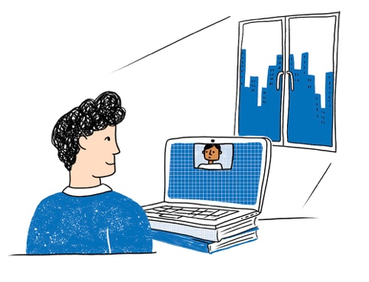  What to do: Have a light source illuminate your face. During the day, it’s great if you can face a window. Even a table lamp behind the computer can work.
What not to do: Don’t look down at your laptop. dIt is a distraction if people have to look up your nostrils | What not to do: Don’t put the video call window on a second monitor if that monitor does not contain the camera being used for the call. | What not to do: Don’t have a bright source of light behind you. It’s distracting and you won’t look good.

